**LONG RANGE FM TRANSMITTER WITH AUDIO MODULATION**

**ABSTRACT**

The aim of this project is to develop a low cost long range FM Transmitter with audio modulation. The FM transmitter has 3 stages, A (VFO) Variable frequency Oscillator (30 mw), a class C driver stage (150 mw) and a class C final power amplifier (1 Watt). Basically every FM Transmitter has to have a Voltage Controlled Oscillator (VCO). This is a high frequency oscillator whose output frequency changes based on the voltage applied at a particular control point. This is a variable frequency oscillator (VFO).Q1 with its associated components form the VFO. The VFO output is fed to Q2. Q2 being an emitter follower does not load the VFO but amplifies the power only. Emitter follower output is fed to the final RF power amplifier Q3, the output of which feeds the tuned circuit. Several capacitors are used on the supply rail for HF filtrations .Feeding the VFO transistor Q1 directly with a microphone at its base it becomes a FM Transmitter circuit. At 12 volt DC it will deliver 1 watt RF power at 9 volt little less. With Yagi antenna at both at transmitter and receiver end looking each other at line of sight distance, the range can be up to 5 KM. The yagi antenna being very big, the design and fabrication details are only provided.

This concept can be extended and implemented in colleges or a university, where the latest happenings in a college can be known to the students by tuning to the frequency using an FM receiver.

**Note:-** **The project is supplied with a stick antenna. However a yagi antenna as per the design supplied can be assembled by the user.**

**BLOCK DIAGRAM**

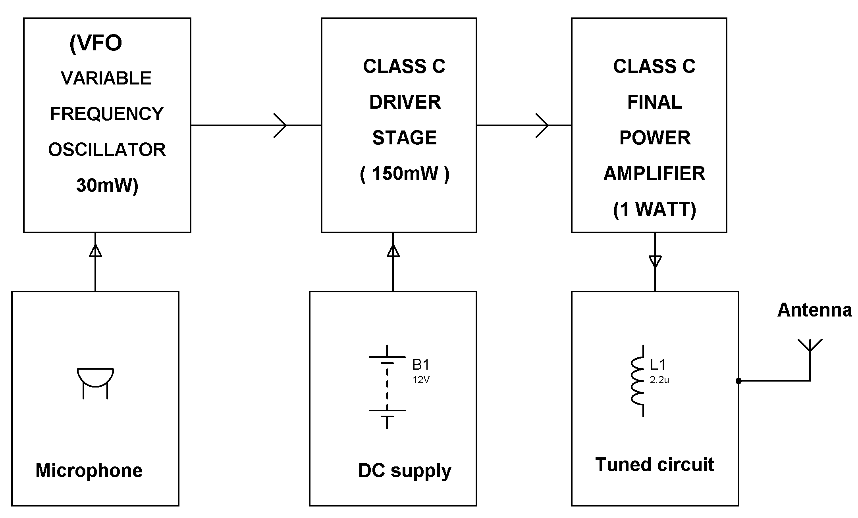

**HARDWARE REQUIREMENTS:**

Transistors, Coils, Resistors, Trimmers, Capacitors, Microphone & Stick Antenna